Mobile Phone Video Production Kit List
By Anthony Quintano
Manager of Visual Storytelling, TD Bank

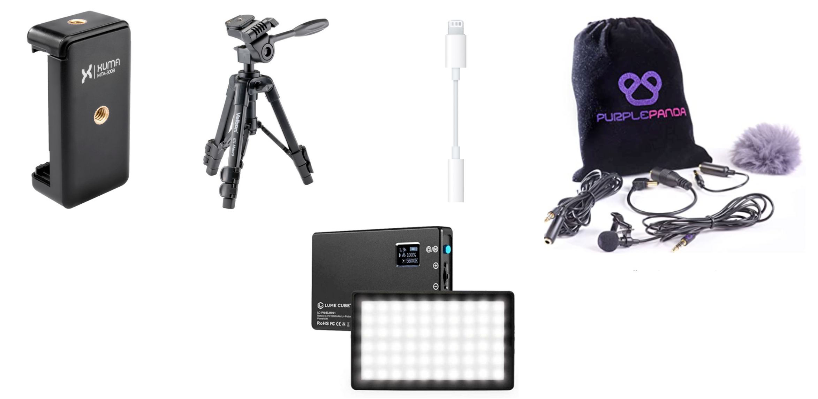

Mobile Phone Tripod Mount: $10
Link to purchase

Tabletop Tripod: $40
Link to purchase

Apple iPhone Headphone Adaptor: $10
Link to purchase

Purple Panda Lav Microphone: $40
Link to purchase

Lume Cube Panel Mini: $60
Link to purchase

