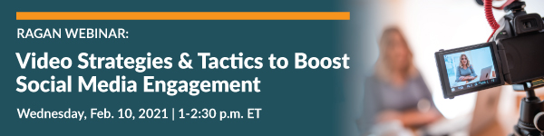

Bonus Materials

Overall Video Tools and Guides

- Lemonlight: The Ultimate Video Marketing Strategy Guide

- Single Grain: Pre-Production Tips to Create Successful Video Content in 2021

- Wordstream: Go-To Social Media Video Marketing Cheat Sheet

- MotionElements: Video Broadcast Templates

- Vimeo: Free Video Templates

- EnvatoElements: Video Templates Service and 10 Top Livestreaming Graphics Templates

YouTube

- YouTube: Brand Resources Collection

- Shane Barker: 13 YouTube Marketing Tools You Need to Know in 2021

- Hootsuite: The Complete Guide to YouTube Marketing in 2020

TikTok

- TikTok: Business Resources Collection

- Pixlee: A Brand’s Guide to TikTok

LinkedIn Live

- LinkedIn: LinkedIn Live Best Practices Guide

- LinkedIn: Getting Started with LinkedIn Live Guide

Facebook Live and Instagram TV (IGTV)

- Facebook: Facebook Live Brand Guide

- Facebook: Facebook Live Broadcast Templates

- Instagram: Video Broadcast Template

- Later: IGTV for Business: 10 Brands Killing it with IGTV Videos

