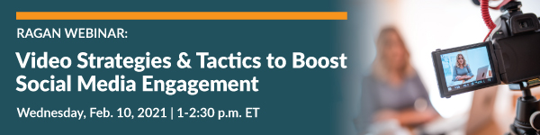

Remote Video & Photo Production Tip Sheet
By Anthony Quintano

Top Tips
- If recording horizontally, all video must be recorded horizontally. Same for vertical video. Don’t switch between formats.
- Unless you’re capturing for Instagram or TikTok, record horizontal video.

Interviews, Takes and Subjects
- Talk with interviewee prior to production process.
- Ask yourself is your subject talking directly to viewers or being interviewed?
- This will determine if your subject will look directly at the camera or slightly just off camera.
- If talking directly to viewers, look at the camera. If it’s an interview, look just off camera.
- Be prepared to do multiple takes.
- Take at least a 15 to 30 seconds breath in between takes. Don’t delete bad takes.
- Remember: The more the subject records a line, the better and more comfortable they get.
- Composing the subject is important. Use the rule of thirds.
- Be aware of the background of your subject. Avoid clutter.

Equipment/Tool Selection & Reminders
- Use highest quality device available (iPhone, DSLR, camcorder)
- Make sure a mobile device has available space for recording.
- If using a mobile device, make sure it is in airplane mode to avoid interruptions.
- Avoid iPads, tablets and webcams, as they tend to be lower in quality.
- Use personal devices vs. corporate devices, as they tend to limit ease of file transfer.
- If using a mobile phone, use a back-facing camera if possible.
- Clean lens of device with a soft cloth (not your shirt).
- If using a front-facing camera, look at the lens and not yourself on the screen.
- Use a tripod, small or large, to hold a recording device.
- You can have someone help you hold the device, but they can get tired and cause shaky video if your video is long.

B-Roll
- Think about B-roll for any interview. This can greatly enhance visual storytelling.
- B-roll can be short clips of whatever the subject is talking about at that moment in the video. These clips can be 5 to 15 seconds long.
- What video or photos can you edit over the subject talking that you can cover any jump cuts/edits or any awkward moments in an interview?

Sound and Lighting
- Use a quiet room with as little background noise as possible.
- Air conditioners, fans, pets, kids, dead batteries in smoke detectors are big noise culprits.
- When you complete a recording of a clip, play it back to check for any audio disruptions.
- Use a room with a lot of natural light.
- Face any windows if possible. Let the natural light be the light for your subject.
- Don’t put your back to any windows or light sources, as they will cause silhouetting.

