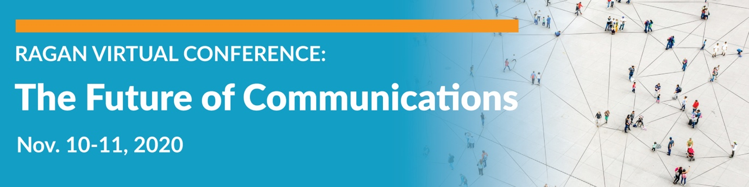

Speaker Contact List

Future of Communications LinkedIn Group

Future of Communications Twitter Speaker List

Beki Winchel
Manager of Strategic Programming
Ragan Communications
@bekiweki
LinkedIn

Meghan Madhavan
Manager of Strategic Programming
Ragan Communications
@MadhavanMeghan
LinkedIn

Michael Kaye
Global Communications & PR Manager
OKCupid
@MichaelKayePR
@OKCupid
LinkedIn

Amanda Schoch
Chief Communications Officer
Office of the Director of National Intelligence
@ajschoch
@ODNIgov
LinkedIn

Richard Levick
Chairman and CEO
LEVICK
@richardlevick
@Levick
LinkedIn

Matthew Roberts
Senior Manager of Consumer Insights and Personalization Analytics
@matthewswrobert
@Adidas
LinkedIn

Angela Juarez-Lombardi
Marketing and Communications, Principal
Pacific Gas & Electric Company
@PGE4Me
LinkedIn

John Kauffman
Senior Manager, Corporate Communications
Pacific Gas & Electric Company
@PGE4Me
LinkedIn

Gladys Hernandez
Director of Marketing & Advocacy
Habitat for Humanity of Orange County
@habitatoc
LinkedIn

Hillary Kwiatek
Employee Communications Specialist
Lehigh University
@hillarykwiatek
LinkedIn

Eric Johnson
Former Producer of “Recode Decode with Kara Swisher”
Vox Media
@HeyHeyESJ
LinkedIn

Jacqueline Rooney
Head of Internal Strategic Response, Internal Communications
Facebook
@Facebook
LinkedIn

Shalini Gupta
Manager of Leadership and CEO Communications
BT (British Telecommunications)
@ShaliniGuptaJ
@bt_uk
LinkedIn

Rachel Lutz
Internal Communications Manager
Deloitte
@Deloitte
LinkedIn

Corine Varga
Sales Enablement Manager
Business Wire
@BusinessWire
LinkedIn

Chris Harihar
Partner
Crenshaw Communications
@ChrisHarihar
LinkedIn

Ben Goggin
Senior Editor of Digital Culture
Insider
@BenGoggin
LinkedIn

Aly Ellis
Director of Social Media
Cheddar
@alyellis
LinkedIn

Kieley Taylor
Global Head of Partnerships, Managing Partner
GroupM
@kieley_taylor
LinkedIn

Michael Delgado
Social Media Director
Experian
@mikedelgado
LinkedIn

Rob Loewenthal
Founder and CEO
Whooshkaa
@whooshkaa
LinkedIn

Lisa Schneider
Chief Digital Officer
Merriam-Webster
@lisaschneider64
LinkedIn

Joel Andren
Founder
Protypical
@ProtypicalPR
LinkedIn

Jon Chang
Global Head of Shopping Growth Marketing
Klarna
@Changahroo
LinkedIn

Elizabeth Lewis
Senior Director, HR and Employee Communications
RBC
@RBC
LinkedIn

Courtney Laws
Director of Human Resources, Change Management and Communications
Maximus
@Courtney_523
LinkedIn

Janet M. Stovall
Senior Director, Social Impact and The UPS Foundation
UPS
@janetmariestov
LinkedIn

Rachel Moore
Social Media Marketing Manager for Talent Acquisition
TTEC
@RachelMooreRS
LinkedIn

Mary Olson-Menzel
Founder and CEO
MVP Executive Search & Coaching
@MVPExecutives
LinkedIn

Melissa Shahbazian
Co-Founder
SparkinSight Coaching
@MVPExecutives
LinkedIn

Valerie Barker Waller
Senior Vice President, Chief Marketing & Communications Officer
YMCA of the USA
@ymca
LinkedIn

Steve Kearns
Marketing Manager, Content & Social Media
LinkedIn
@stevektweets
LinkedIn

Katie Kern
Partner and COO
Media Frenzy Global
@KatieKern
LinkedIn

Lee Deas
Principal, Co-Founder
Obviouslee Marketing
@obviouslee
LinkedIn

Neil Alumkal
Founder and President
Stuntman PR
@stuntmanpr
LinkedIn

Katie Liston
Head of Marketing
ContactMonkey
@ContactMonkey
LinkedIn

Emily (Hartwig) Mekstan
Senior Manager of Retail and Owned Brand Communications
Walgreens
@emilymekstan
@WalgreensNews
LinkedIn

Cheryl Smith
Publisher
I Messenger Media
@NABJ
LinkedIn

Gregg Castano
Founder and CEO
News Direct
@NewsDirectCorp
LinkedIn

Allie Zahn
Corporate Communications Senior Manager
NI (National Instruments)
@NIGlobal
LinkedIn

Naomi Jones
Communications and Marketing Director
SUEZ Recycling and Recovery UK
@NaomiLJones1
@suezUK
LinkedIn

Allison Jackson
Director of Corporate Communications
KPMG
@allyjackson
LinkedIn

Mike McNeilly
Enterprise Account Executive
PoliteMail
@PoliteMail
LinkedIn

Al Hopper
Owner and Founder
Full Deck Coffee
@AlHopper_
LinkedIn
Full Deck Coffee

Tina McCorkindale, Ph.D., APR
President and CEO
Institute for Public Relations
@tmccorkindale
@InstituteForPR
LinkedIn

Heather Kernahan
CEO
Hotwire Global
@hotwireglobal
LinkedIn

Emma Almond
Director of Global Strategic Communications
ManpowerGroup
@ManpowerGroup
LinkedIn

Kathryn Campbell
Director of Research and Insights
Ticketmaster
@sparks_kc
LinkedIn

