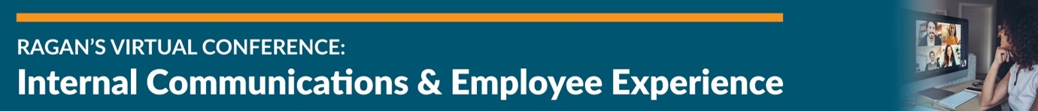

Speaker Contact Information
Event LinkedIn Group

Shira Miller
Chief Communications Officer
National DCP
@theshiramiller
LinkedIn

Leigh Ann Christovich
Assistant Vice President of Internal Communications
Ochsner Health System
@OchsnerHealth
LinkedIn

Tia Mason Howard
Internal Communications Director
MedStar Health
@TiaMHoward
LinkedIn

Nicole Haddenham
Managing Director of Employee Experience and HR Product Management
Charles Schwab
@nicjoy
LinkedIn

Janis Avila
Director of Employee Experience
Facebook
@Facebook
LinkedIn

Sameer Chowdhri
Global Head of HR Solutions
Workplace from Facebook
@WorkplacefromFB
LinkedIn

Kim Clark
Diversity, Equity and Inclusion Consultant
Ragan Consulting Group
@KimClark1
LinkedIn

Mary Olson-Menzel
Founder and CEO
MVP Executive Coaching & SparkinSight
@MVPExecutives
LinkedIn

Melissa Shahbazian
Co-Founder
SparkinSight
@MVPExecutives
LinkedIn

Katharine Crallé
Director
Brunswick Group
@BrunswickGroup
LinkedIn

Michael DesRochers
Founder and Managing Director
PoliteMail Software
@PoliteMail
LinkedIn

Lucy Abreu
Senior Vice President
Syneos Health Communications
@LucyAbreu
LinkedIn

Sean Greenwood
Grand Poobah of PR
Ben & Jerry’s
@PRPoobah
LinkedIn

Tara Davis
Director of Staff Well-being and Engagement
American Psychological Association
@letswearlove
LinkedIn

Mary Davis Kaplan
Strategic Solutions Engineer
LumApps
@lumapps
LinkedIn

Heather Shaw
Manager of Strategic Communications
Deloitte
@Deloitte
LinkedIn

Laura Hammett
Head of Employee Measurement and Insights
bp
@bp, @bp_UK
LinkedIn

Tina McCorkindale
President and CEO
Institute for PR
@tmccorkindale
LinkedIn

Jonathan Jordan
Senior Vice President, Employee Experience & Business Transformation
Edelman
@EdelmanPR
LinkedIn

Beki Winchel
Manager of Strategic Programming
Ragan Communications
@bekiweki
LinkedIn

