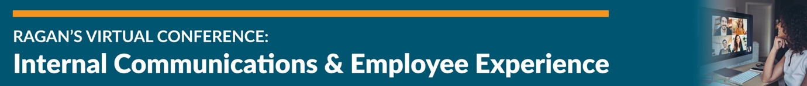

American Psychological Association Resources
Courtesy of Tara Davis, Director of Staff Well-Being and Engagement, American Psychological Association

APA’s Help Center: A resource featuring information related to psychological issues affecting your daily physical and emotional wellbeing. The articles are written by psychologists or include psychological science to deal with a variety of topics such as COVID-19, anger, willpower, healthy habits for families, anxiety and more.

APA’s Resources for Employers: A full-fledged resource for organizations and how they can become healthier, support employee wellbeing and more.

APA’s Model of a Psychologically Healthy Workplace

APA’s Resources for Racism, Bias and Discrimination

APA’s COVID-19 Information and Resources

