Ragan’s Social Media Conference for PR, Marketing
and Communications Professionals
March 11-13, 2020
Burn After Reading

Includes notes from:
- 'Be prepared': Addressing COVID-19 and stopping misinformation's spread, with Caitlin Angeloff, Providence Stl. Joseph Health and Rebecca Mueller, Porter Novelli

- ‘What a day’: Taking advantage of live events and trends, with Alyssa Velazquez, ViacomCBS

- ‘Remember me’: Tell a story with your metrics and prove social media ROI with John Young, Southwest Airlines

- ‘Checkmate’: Secrets of social media content that reaches and resonates with Carolyn Reams, CIA

OPENING FIRESIDE
'Be prepared': Addressing COVID-19 and stopping misinformation's spread
Speakers: Caitlin Angeloff, Providence St. Joseph Health and Rebeca Mueller, Porter Novelli

Providence St. Joseph Health needed/needs to:
- Expand their footprint—went from posting once daily to twice daily

- Leaninto partnerships: Sprinklr expanded their options for them and Microsoft built a chat bot for them in four days

- Overcommunicate – if there was something they’d change, it would be to communicate more

- Help stop the spread (for COVID-19, that’s “flattening the curve”)

Remember, there are waves to the crisis and the communications

Make sure you have your communications objectives written down. For Providence, they are:
- Communicating that they should be trusted and have the public’s best interest in mind
- Educating, educating and educating
- Working with community partners
- Battling misinformation both internally and externally

Look to authorities at points of crisis
- Twitter was the first platform to link to the CDC as the source of COVID-19 information
- Facebook just opened their advertising offerings to the CDC, free of charge
- Both the Department of State and the CDC are current authorities

Our human nature is to react, but in times of crisis, you need to respond.
- We need to learn and make mistakes and adjust—and we need to work together.
- It’s OK to ask for help.

Who should you have on your team?
- Head of internal communications
- Head of legal
- Head of PR
- Chief risk officer
- Pre-identified spokespeople (based on expertise to the crisis)
- Head of social media
- Head of operations, so you can mobilize and put it into working order

According to the Institute for PR study, news media and U.S. leaders were lumped in with social media at the low end of the trust scale—they were not seen as credible.
- You’ve already built up followers and credibility with your community, so you can become the source of information that audiences trust.

What’s your business continuity plan?
- This is the plan that gets activated when your company goes through a crisis (any crisis, including a pandemic, a natural disaster, etc.)
- The content you create under your plan can now be shared across your social media channels and on your own website.
Your whole team must involved and mobilized.

Tip: “If your crisis communications plan is not in effect, you’re behind.”

Tip: To make sure everyone is in lock step: “There is a great need for communicating through traditional means.”

Tip: Have a set of tools that allow you to communicate in real time

Tip: “At a time of crisis, the most important thing you can do is have a consistent message.”

Tip: Questions cause fear, fear causes panic.

Tip: The biggest thing is to have your message, pair it with a call to action, and keep driving that message home.

Tip: Craft your message to the audience you’re talking to – whether it’s internal, external, C-Suite, etc.

OPENING KEYNOTE
‘What a day’: Taking advantage of live events and trends
Speaker: Alyssa Velazquez, ViacomCBS

For those who ask: Why don’t you play music videos anymore?
- About 1/3 of consumers have a digital subscription—they’re moving from TV to online platforms (PlutoTV, digital publishing, etc.)
- They’re digital publisher
- The community managers know the audience and it’s a “cooler,” older sibling vibe
  - They posit a genderless presence, but the voice does skew a little more female (14-24 years old)
  - The platforms for MTV’s social media presence (They focus on Facebook and Twitter—the most engaged audiences and engagement, and Facebook has the widest audience across demographics):

- Facebook: 48M
- Twitter: 15.8M
- Instagram: 11.7M
- TikTok: 3.7M
- Snapchat: 3 M
- YouTube: 6.4M
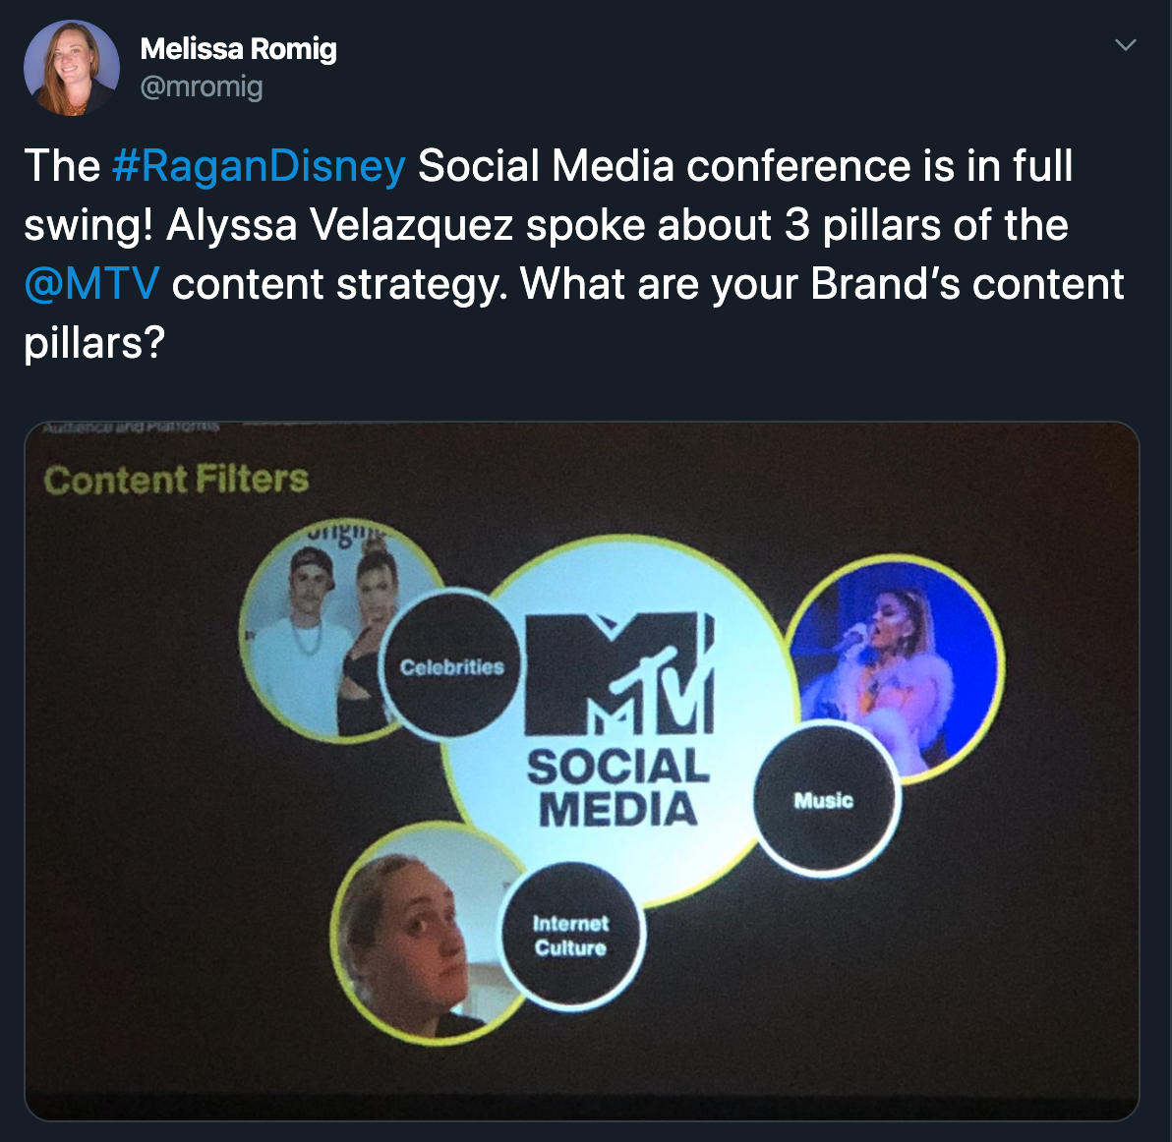

They take part in a lot of events—they cover roughly one event each month:
- MTV’s VMAs (Vide Music Awards) – their largest, because they own this
- Lolapalooza
- The Met Gala
- BET Awards
- The Grammys
- New York Fashion Week
- The Oscars
- VidCon
  - Challenged with event coverage, because there wasn’t the red carpet
  - Covered with a new angle and in a way no one was doing, which brought them new sponsorship opportunities

Tiered social media coverage plan
- Tier 1,2 and 3
- On the ground vs. covering remotely
- You don’t need a lot of resources—an iPhone can do it
- Handle each platform’s point of view differently.
  - Instagram Stories: Behind-the-scenes access, unpolished, timely (will often hand it off to a celebrity) –as timely as you can make these, the more return you’ll receive
  - Instagram Feed: More curated and polished, still timely
  - Twitter: Reactionary and not as curated as the other platforms
  - Facebook: Usually they wait until the end of the night. FB suggests longer-form content, but they play around with it.
  - Snapchat: Offer as a “takeover” with a celebrity

During the Grammys coverage, MTV changed its tone to adjust after Kobe Bryant’s death. It was a risk they hadn’t taken before—but it paid off. They were the 6th most engaged account for the event.

At the end, they pivoted and did a montage of celebrities reacting to Kobe Bryant’s death.

Takeaways:
- Be flexible to change your plans and pay attention to social listening. If you don’t, your strategies can backfire!
- Pay attention to trending hashtags—locally, internationally, etc.
- Monitor the social media conversation
- Remain authentic, no matter your message
- Share high quality images and videos
- Be timely, bur purposeful.

Take away insights:
- What won? What tanked? Adjust your strategy to play up on the successful posts and dump those that didn’t work.
- Ask yourself how you can kick it up a notch next year and experiment more. How can you challenge yourself and your strategy?
- Taking risks can bring big rewards!

Tip: “We’ve seen the most engagement when we’re the first to post about something.”

Tip: “Repeat, evolve and experiment.”

Tip: Twitter and Instagram are the best platforms for real-time events coverage

MAIN SESSION
‘Remember me’: Tell a story with your metrics and prove social media ROI
Speaker: John Young, Southwest Airlines

Southwest Airlines is “customer centric to the core.”
However, you should advocate to your customer and make that a focus of your social media strategy and outreach.

“We manage in good times, so that all of us will be protected from bad times when they come.” – Southwest’s creed, via founder Herb Kelleher

How do we show to our leaders the value of connecting with people on social media?

- Start with benchmarking.
- Look at your competitors OR leaders on social media, to see what resonates, what’s awesome and what you could accomplish.

- Make the business case. You’re not just fast to please customers—realize that you’re spinning up more cost if you don’t respond quickly (they’ll email, call, use a chat, etc.) – that’s how you sell the business case to leaders.
  - Example: “We could respond faster than the competition if we had more head count.”
  - (“I don’t want to just respond to you—a bot could do that.”)

Industry level rankings to consider:
- Response time
- Team capabilities
- Volume
- Channel presence
- Response rate
- Response type

Traditional metrics

Agents
- Average handle time
- Time to resolution
- Number of cases handled

Channels
- Cases
- Cost per case
- Cost per touch (artificial intelligence plays in here)

Brand
- Stories curated
- Influencers engaged
- Calls deflected
- Ad spend saved

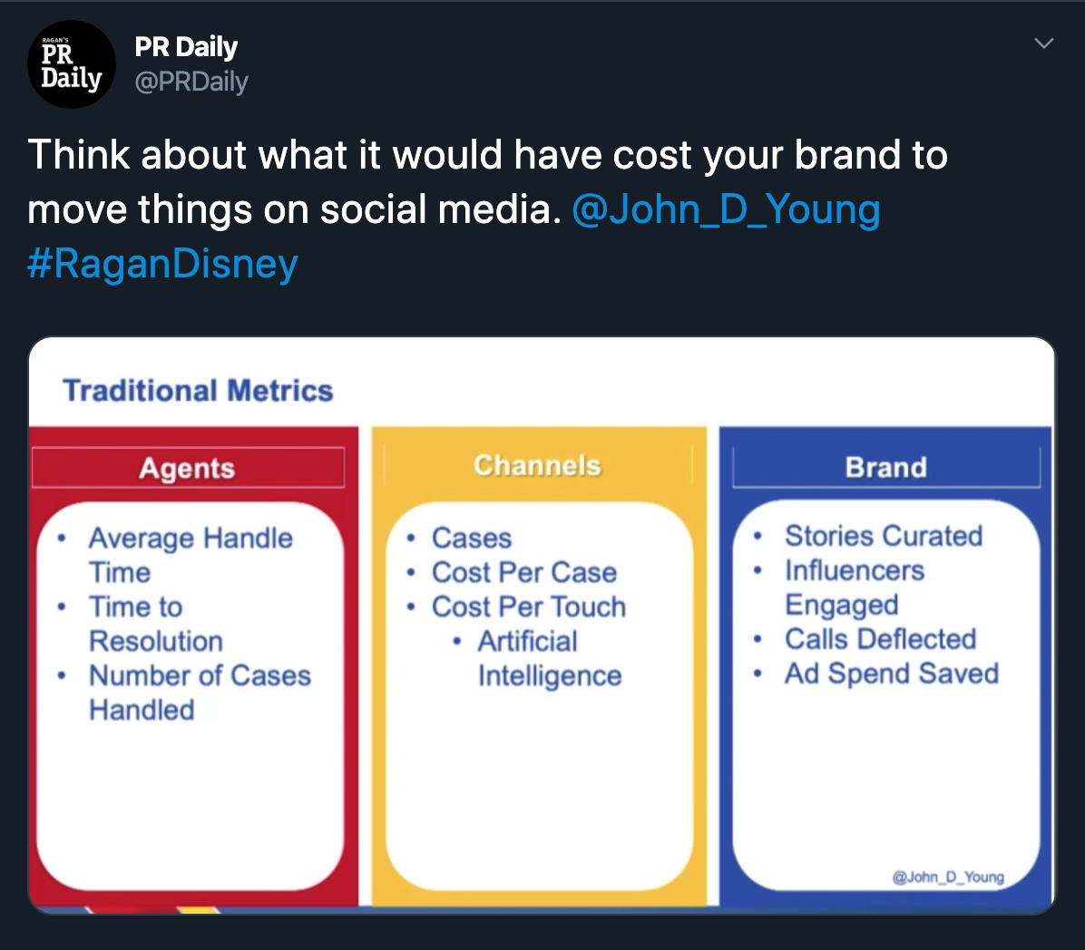

The new ROI values

Retained customer value
- 11% of churn can be resolved through company outreach
- Responding on social media retains customers
- Key metric: Annual Customer Value

Community Forums
- Call deflections
- SEO benefits
- Brand Advocates
- Self service options
- Sales opportunities
- Key metrics: Call Deflection Value, Sales Lead

Call Deflections
- Smart social media can solve issues
- Identify contact drivers and produce content to maximize ROI
- Key metric: Call Deflection Value

Referrals
- What’s the impact from your social channels to your.com, FAQs, and other channels?
- Key metrics: Sales Lead Value, Social Ad Value Equivalent

Sentiment is more than comments!
- Facebook reactions
- Shares
- Comments
- Negative actions
- Emojis
Make sure your sentiment tool covers all of this—or get rid of it!

Net Sentiment Formula
Positive engagements – Negative engagements = Total

Positive:
- Likes
- Loves
- Haha
- Wow
- Positive Comments
- Shares
- Emojis

Negative:
- Dislikes
- Sad
- Angry
- Negative comments
- Hide
- Hide All
- Spam
- Unlike Page

Total:
- Likes and reactions
- Comments
- Actions
- Shares

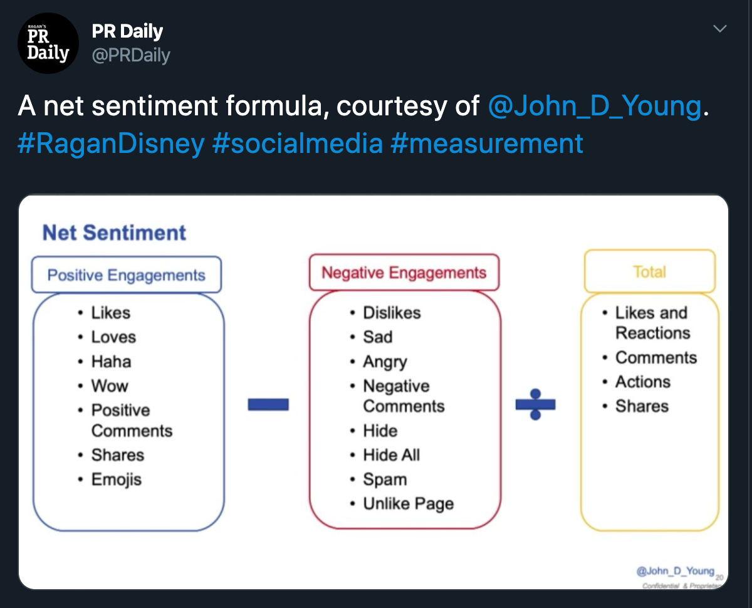

Here’s what you can do:
- Establish benchmarks.
- Identify cost models for agents, channels and brand\Mature into more advanced insight metrics.
- Make sentiment reporting more accurate.
- Track to the outcomes that move your business forward.

Tip: “We need to work together to make social media suck less.”

Tip: Social media needs to be a place where we get educated and entertained and connect.

Tip: “At the end of the day, you’re still selling a business.” (Though it can be hard to put a price tag on metrics and social listening, you have to show ROI and put things in business terms).

Tip: What do you empower your front-line reps to do? Can your social media team handle things without a customer picking up the phone?

OPENING KEYNOTE
‘Checkmate’: Secrets of social media content that reaches and resonates
Carolyn Reams, CIA

Why should you embrace social media? “Conversations happen with or without you.”
- People expect content to come to them.
- They want all of the information pushed to them—they don’t want to search for it
- The CIA has 15 million pages on its website, and without curating/pushing them out, people miss it.

Social media can humanize your organization.
- CIA looks to historical figures for stories to share.
- Sometimes on the anniversaries of historical figures’ deaths, they’ll share memorials.
- CIA’s social media presence and mission is to share that they’re “normal people doing extraordinary things.”

What does CIA share (and what can you share)?
- Current events: conferences and events at which they speak
- What others are taking about (ex: Pride Month and Shark Week)—but make sure it ties back to your organization
- Useful stuff (ex: training tips for National Dog Day)—share helpful information and takeaways
- Reoccuring content: Evergreen content and stories you can share any time
- A story told in a new way/angle (ex: Comparing “Argo” film to the actual event)

Why you should tweet like a museum exhibit:
- Information is easily accessible
- It’s easy to understand and absorb
- It’s relatable
- It contains a visual
So, why should social media be any different?

Skimmers, Swimmers and Divers: The three types of people who attend an exhibit (and who view your social media content)

- Skimmers: Scan your content and will only take the short soundbites from your content.

- Swimmers: Will click the link and read the story you share with your content.

- Divers: Will keep clicking away (additional links within the story you share), and you can offer more information and ways to learn about your organization/engage.

The point is to convert skimmers to swimmers, and swimmers to divers.

Make your social media content eye-catching by taking a risk/trying something new.
- Dr. Zhivago tweet promoting the book by translating its first message in Russian.
- Then followed up with additional information, visuals, etc.
- Don’t make it complicated: Select one tweet or visual as your focal point, and create content and messages around that.

Play off a popular trend by tying it into your organization.
- “Hamilton”—CIA shared the story of Hercules Mulligan the “spy on the inside.”
- Make sure your tie-in makes sense and select the right time, so it doesn’t seem too desperate or “thirsty.”

Things to think about when creating your own content:
- Creativity: How can you think of things in a new way that still matches your mission?
- Applicability: Don’t just throw things out to throw things out.
- Timing: Is there a more appropriate time to put out that content you’ve created?
- Simplicity: It can be more effective to tweet one or two things and focus on them instead of creating ALL THE THINGS.

It took CIA roughly 11 months to get permission, so keep working on getting buy-in for your effort.
- Make the business case and explain how your idea is a good risk
- Outline the potential upsides and gains

Tip: Most of CIA’s social media content is serious. Not everything you share has to be humorous, sassy or controversial.

Tip: It’s OK to save your content for another time when you can get more eyeballs on it or when it becomes more appropriate.

Tip: Use your social media presence and content to highlight lesser-known qualities about your organization.

Tip: Remember, it’s not just about you.

Tip: “You have to meet people where they are.”

Tip: “Be the official voice for your organization.”

