twitter guide
For iPhone / Last Updated: August 2018

TWITTER LINGO
Word | Definition
The @ sign | Think of this as you do an email address. The @ sign precedes a username or "handle" whenever you want that user to see a tweet
Mention | When someone mentions you in a Tweet
Reply | When someone replies to your Tweet, or they simply want to talk to you publicly, they'll start the Tweet with your username
Public reply | When someone uses the reply method to reach out to you, by putting your username at the front of their Tweet, they make that post semi-private. Since it's a reply, the only people who will see it are you and the people who follow both of you. To make it public, some users will add a period before the username, like this: .@username just shared a slice of pizza with me, it was so good!
Hashtag (#) | When the pound symbol is added to a word, it turns it into a link -- a hashtag. That link automatically creates a feed of Tweets from anyone using the same hashtag
Follow | When you are "following" someone, you are subscribed to their Tweets. Most Twitter accounts are public and can be seen by anyone, but if you want someone's Tweets to show up in your main home feed, you have to follow them first.
Direct Message (DM) | If you are following someone, and they are following you back, you are then allowed to Direct Message them. These are the only truly private messages between two users on Twitter.
Retweet (RT) | When you re-share something that’s already posted

HOW TO…HOMEPAGE
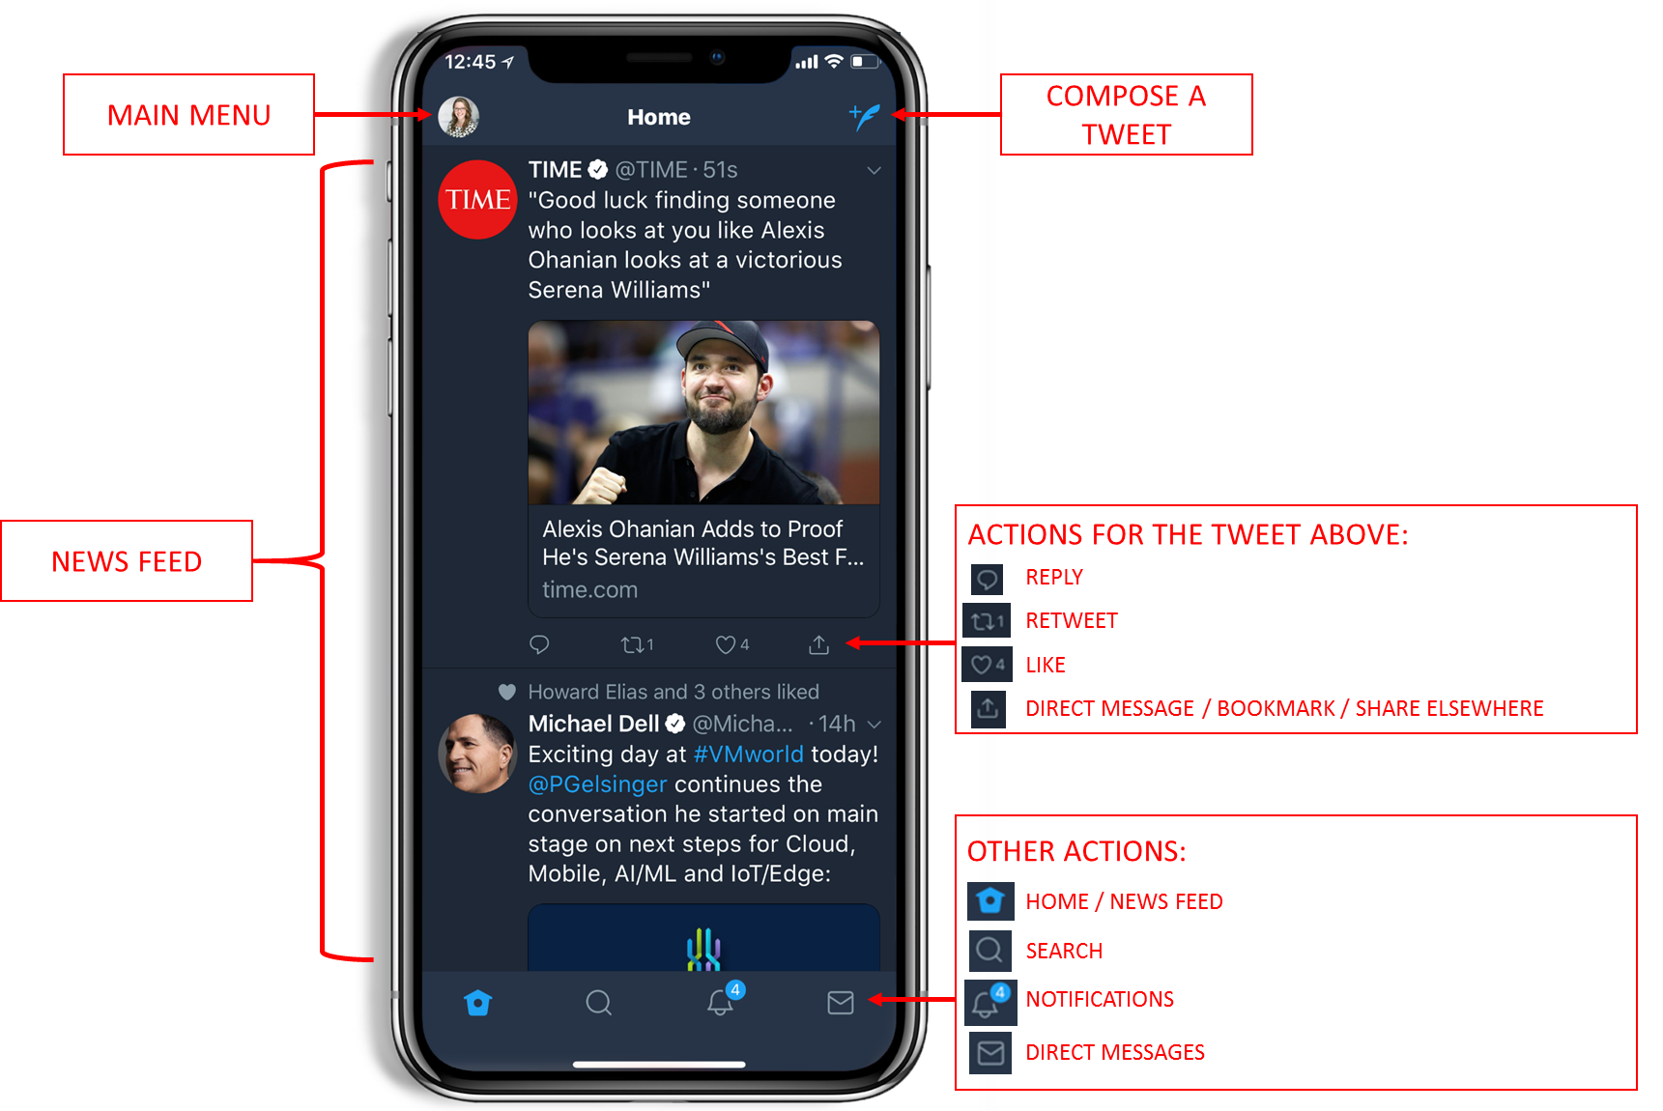

HOW TO…MAIN MENU
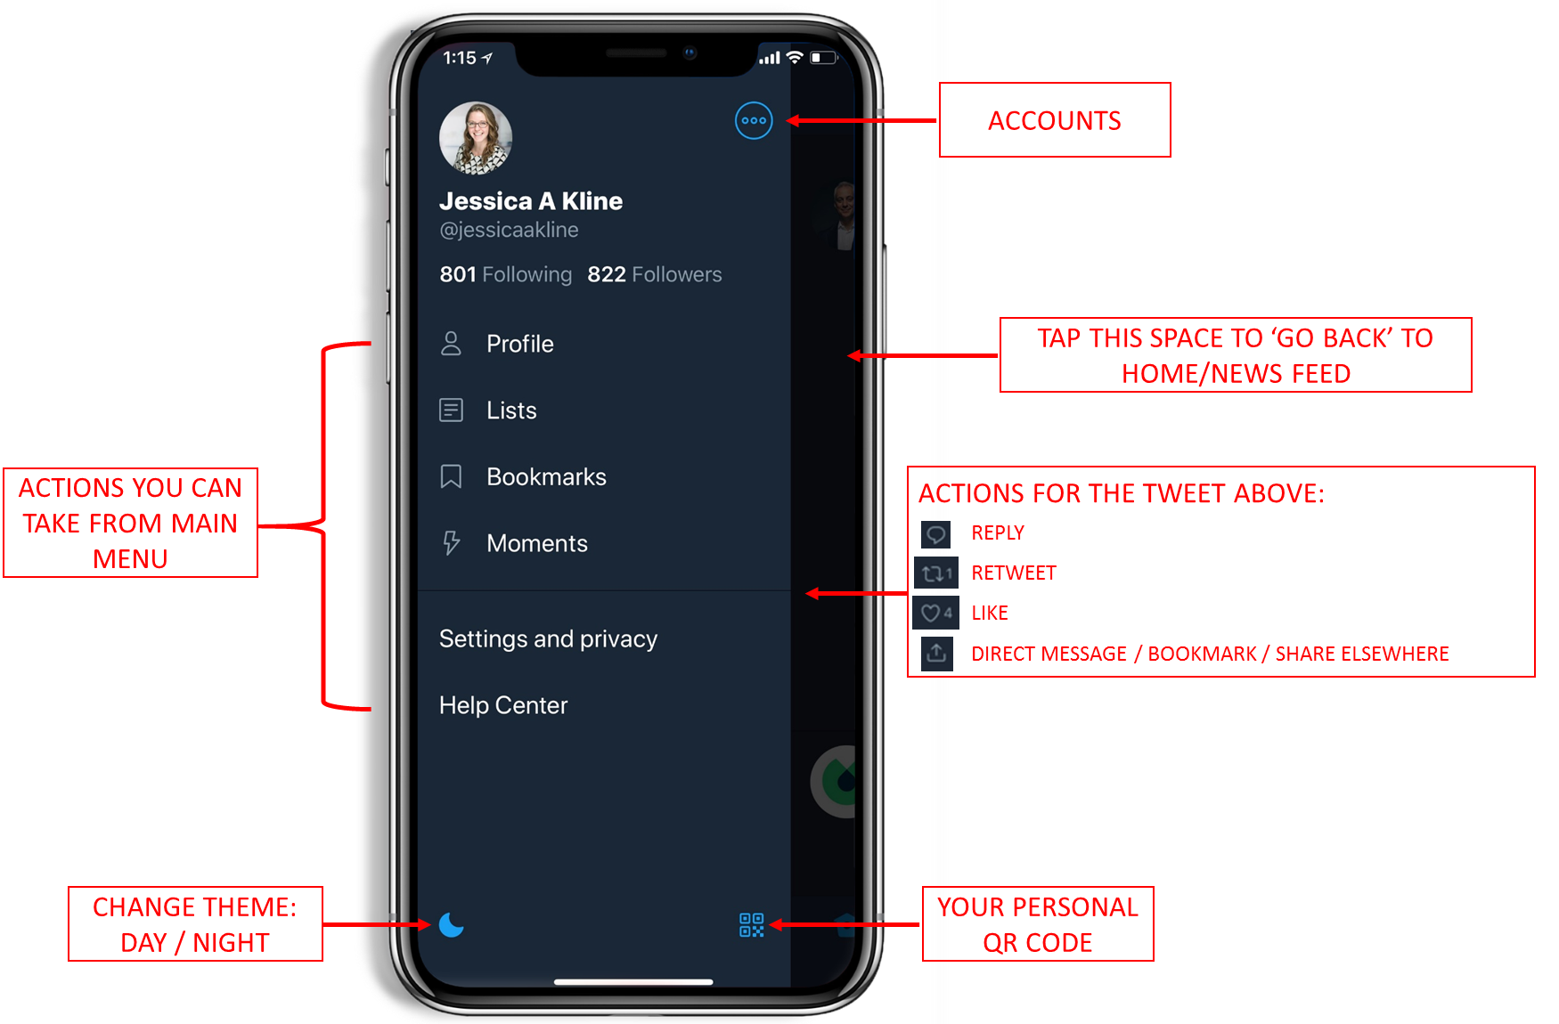

HOW TO…YOUR PROFILE
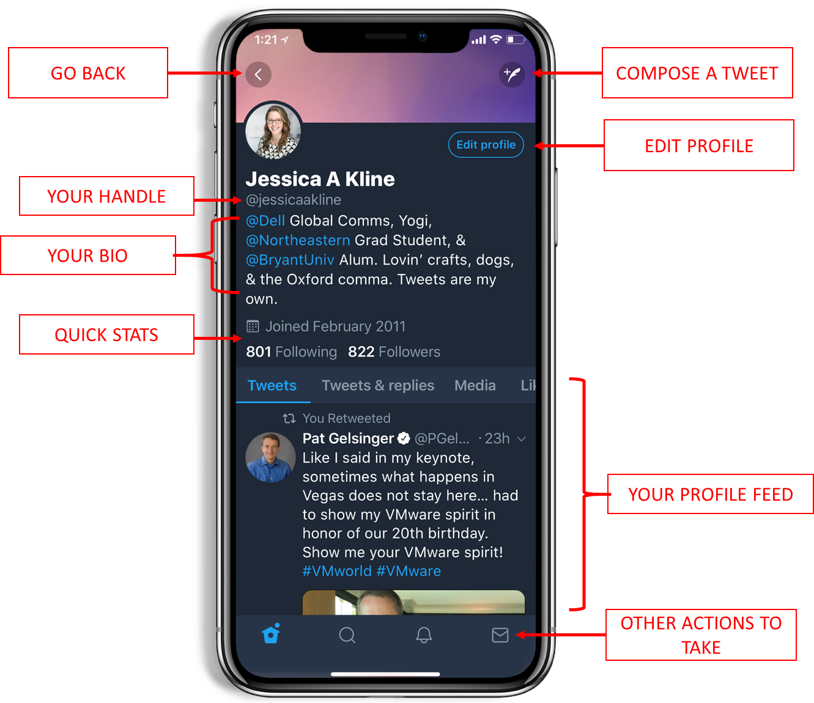

HOW TO…COMPOSE A TWEET
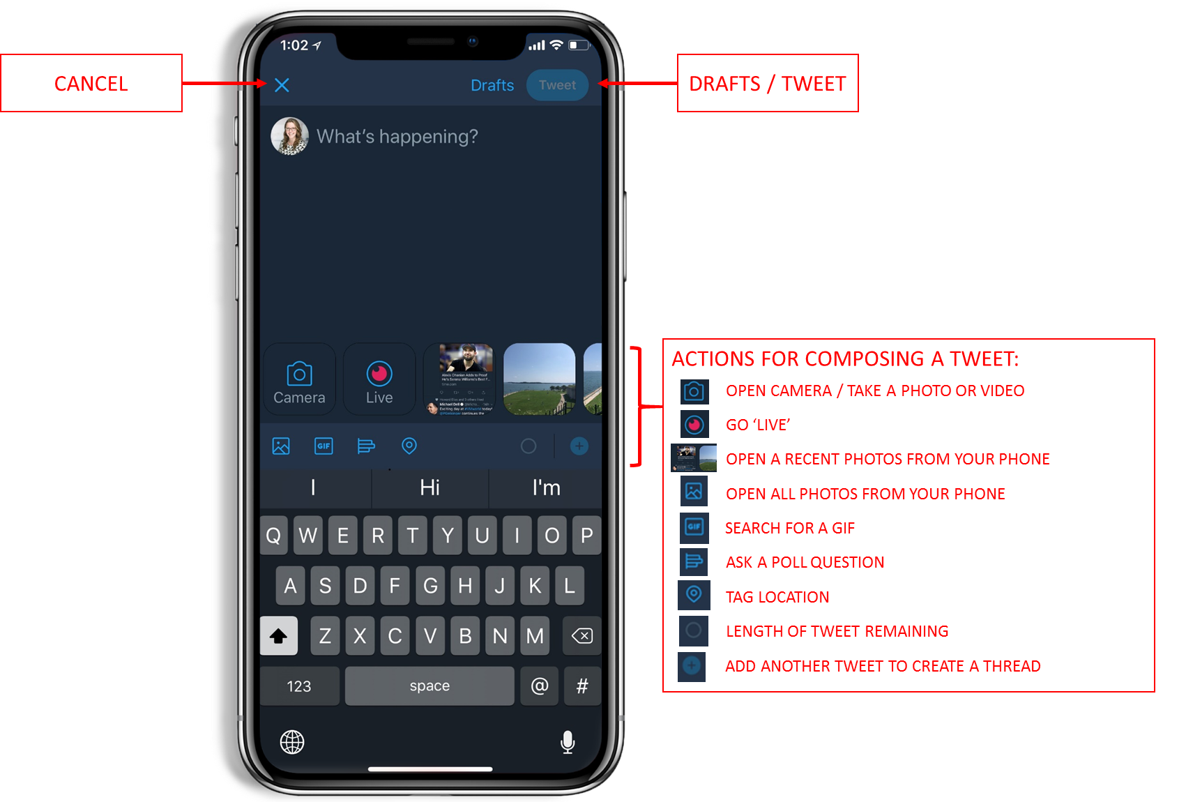

HOW TO…SEARCH
